21.100: 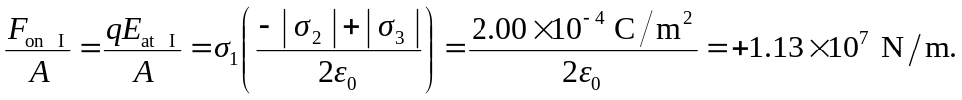
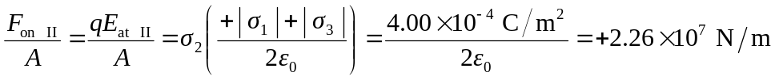
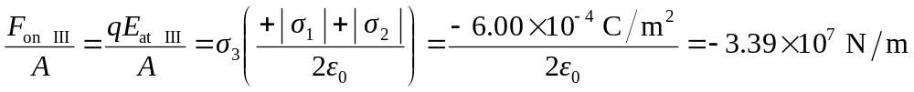
(Note that “+” means toward the right, and “–” is toward the left.)

